

**Data Brief: Confirmed Unintentional/Undetermined1 Opioid-related2 Overdose Deaths Among Massachusetts Residents – Demographic Data Highlights**

Massachusetts Department of Public Health Posted: AUGUST 2016

This data brief highlights demographic data from confirmed overdose deaths from January 2016 to June 2016.

**Confirmed Unintentional/Undetermined1 Opioid-related Deaths by Gender:**

**January 2016-June 2016**

|  |  |
| --- | --- |
| **Unintentional/Undetermined Opioid Deaths by Gender:**  **January 2016-June 2016** | |
| Male | 365 |
| Female | 123 |
| **Total** | **488** |

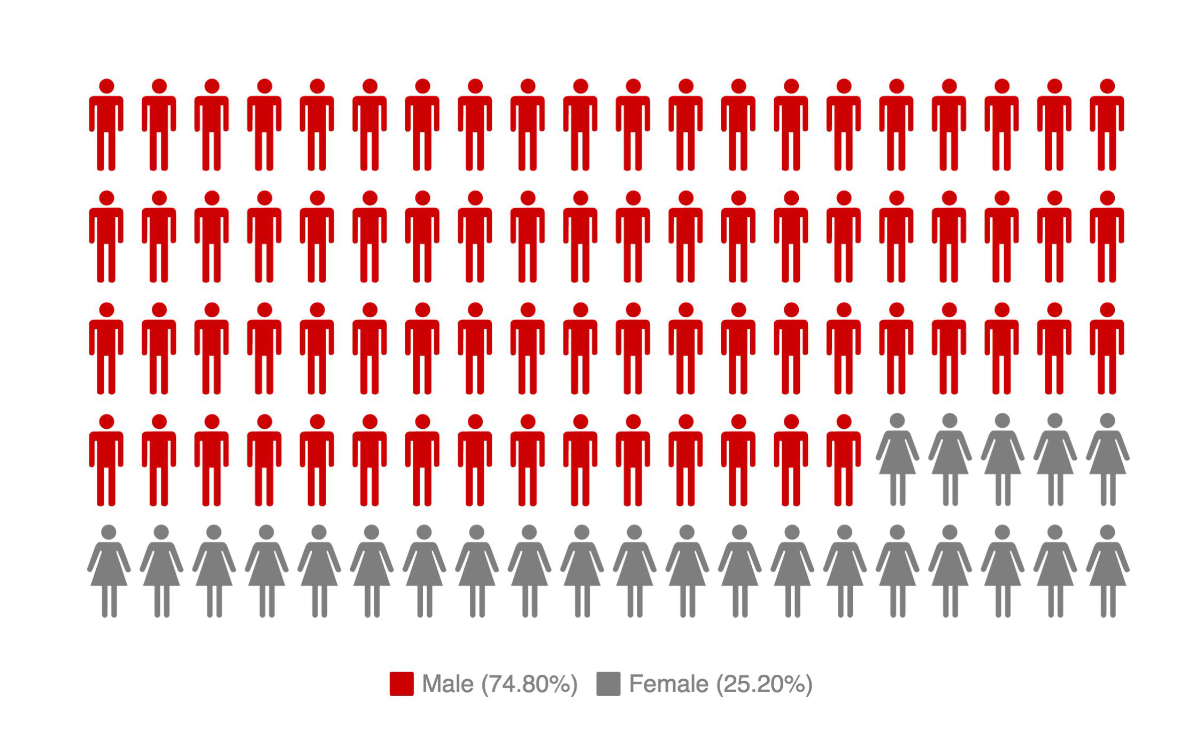

1 Unintentional poisoning/overdose deaths combine unintentional and undetermined intents to account for a change in death coding that occurred in 2005. Suicides are excluded from this analysis.

2 Opioids include heroin, opioid-based prescription painkillers, and other unspecified opioids.

**Confirmed Unintentional/Undetermined1 Opioid-related Deaths Compared to All Deaths by Age: January 2016-June 2016**

|  |  |  |  |  |  |  |  |  |  |
| --- | --- | --- | --- | --- | --- | --- | --- | --- | --- |
|  | **Deaths by Age: January 2016-June 2016** | | | | | | | | |
|  | **0-14** | **15-24** | **25-34** | **35-44** | **45-54** | **55-64** | **65+** | **Unknown** | **Total** |
| All Deaths | 166 | 209 | 569 | 645 | 1,459 | 2,916 | 21,074 | 4 | **27,042** |
| Confirmed Unintentional / Undetermined1 Opioid Deaths | 0 | 41 | 165 | 126 | 103 | 50 | 3 | 0 | **488** |

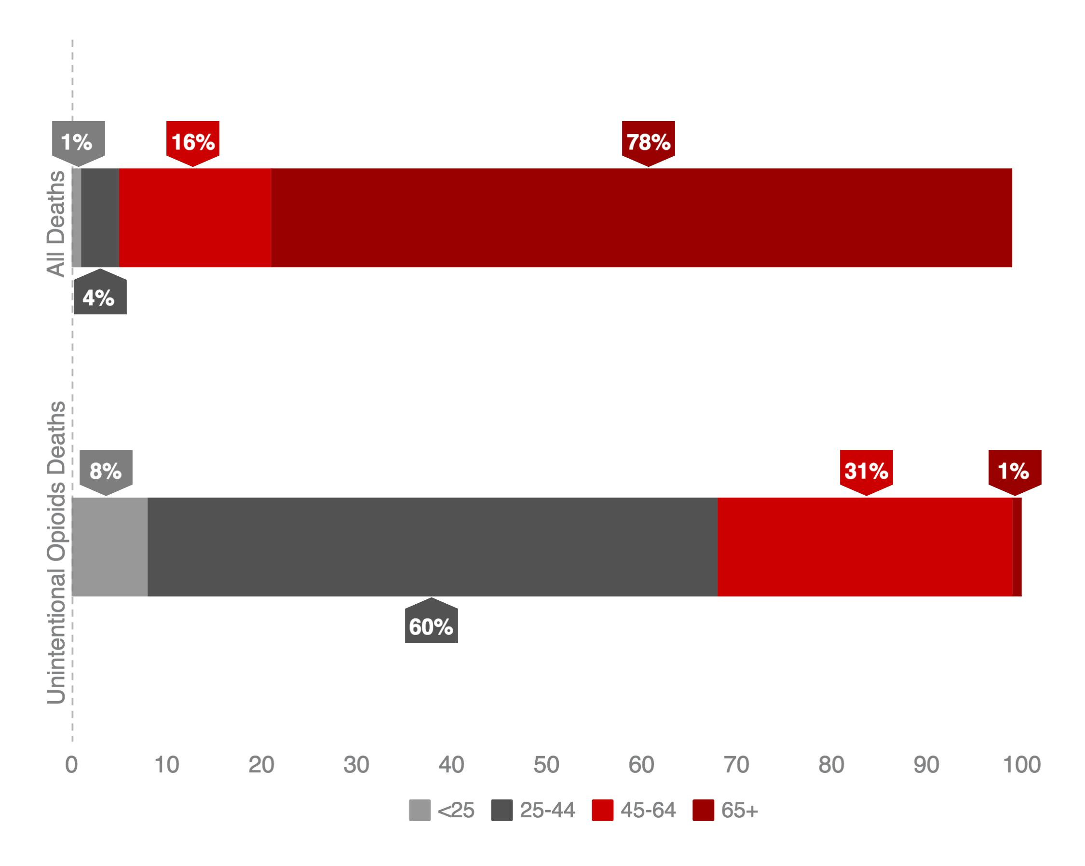

Note: Due to rounding, percentages under “All Deaths” do not add up to 100%.

1 Unintentional poisoning/overdose deaths combine unintentional and undetermined intents to account for a change in death coding that occurred in 2005. Suicides are excluded from this analysis.

**Confirmed Unintentional/Undetermined1 Opioid-related Deaths Compared to All Deaths by Race: January 2016-June 2016**

|  |  |  |  |  |  |  |
| --- | --- | --- | --- | --- | --- | --- |
|  | **White non-Hispanic** | **Black non-Hispanic** | **Asian non-Hispanic** | **Hispanic** | **Other/**  **Unknown** | **Total** |
| All Deaths | 24,163 | 1,156 | 483 | 961 | 279 | **27,042** |
| Unintentional/Undetermined1 Opioid Deaths | 391 | 19 | 4 | 67 | 7 | **488** |

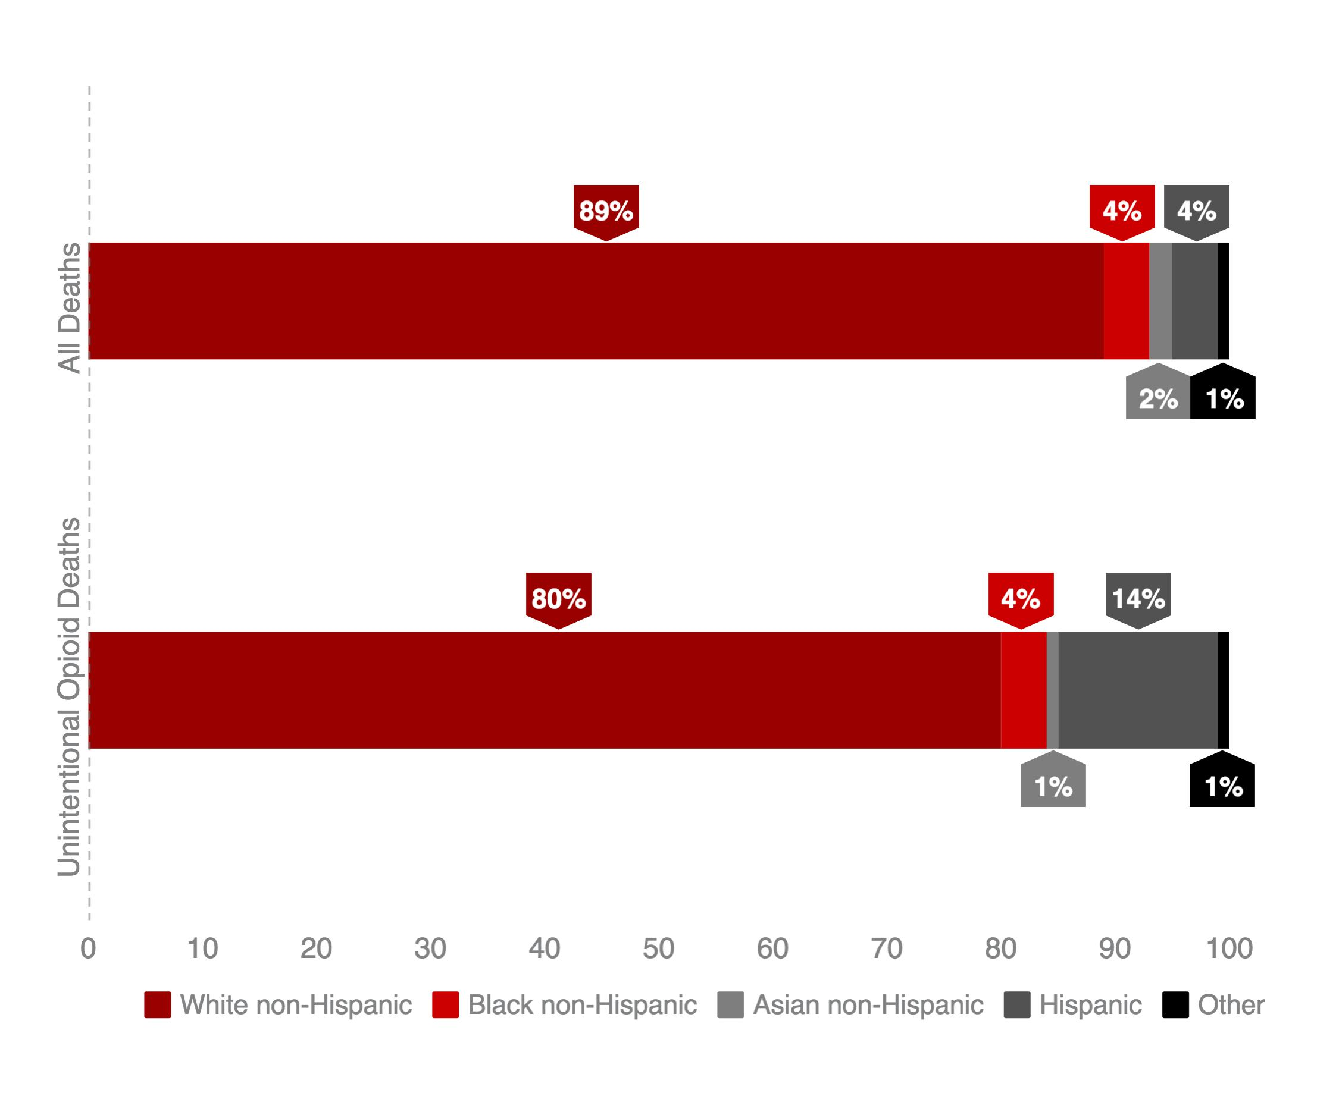

1 Unintentional poisoning/overdose deaths combine unintentional and undetermined intents to account for a change in death coding that occurred in 2005. Suicides are excluded from this analysis.

**Technical Notes**

2016 death data are preliminary and subject to updates. Case reviews of deaths are evaluated and updated on an ongoing basis. A large number of deaths have yet to be assigned final cause-of-death codes. The information presented in this report only includes confirmed cases. Data updated on 06/30/2016.

**Source: Registry of Vital Records and Statistics, MDPH**